St. Edward’s University Website – www.stedwards.edu
Quick Reference Guide: Faculty Profiles
Last Updated: 10/20/15

Table of Contents:

Overview
Who’s This Document For?
Website Goals
How Often Should I Update Content?
For Help
Getting Started
Faculty Profile Information Checklist
Website Tour
Sample Faculty Profile Page
How-to Guide
Finding your Profile
Editing your Profile
FAQs

Overview
The faculty profiles are intended to be flexible and allow for you to accurately showcase your professional, academic career and highlight unique achievements. This profile framework was developed in conjunction with St. Edward’s University faculty (full time and adjunct) in late 2014 and early 2015.

Each faculty member will be responsible for the...
- accuracy of their own information
- maintenance of their profile

Who’s This Document For?
This document is a quick reference guide for faculty who wish to update their official St. Edward’s website profile.

Website Goals
The current version of the St. Edward’s University website was launched to the public in July 2015. In Fall of 2014, the following goals were established as the guiding principles for the web presence. It is critical to keep these goals in mind as new content is added.
- Goal 1. Increase awareness of the St. Edward’s brand and enhance the reputation of St. Edward’s as an intellectual and scholarly center.
- Goal 2. Increase quality and number of students in all academic programs
- Goal 3. Establish a website that provides a consistent user experience for internal and external stakeholders to gather information and execute tasks quickly and efficiently.

How Often Should I Update Content?
Any outdated or incorrect content can and should be updated regularly. However, it is recommended that your profile be refreshed every six-to-12 months.

For Help
Please contact support@stedwards.edu with technical questions.

Getting Started

Faculty Profile Information Checklist
General rules of thumb:
- When possible, link to additional source information (articles, presentations, videos, etc)
- List most recent items first

General Information
- Image (Your official St. Edward’s headshot. Check with Marketing to attend next photoshoot.)
- First Name
- Last Name
- Display Name (If you prefer an alternative to what’s in the official HR system)
- Phone
- Office Location
- Office Location Detail (ex. Sorin Hall 213)
- Campus Mailbox
- Titles
- Office Hours (ex. M 9:00am - 10:00am)
- Summary (up to 300 characters)
- Bio (up to 700 characters)
- Education (Bachelors, Masters, Doctoral Degrees)
- CV (Your resumé in PDF format)

Optional Information:

Overview  - Personal Statement  (Appears in larger gold font, as a “quote”)  - Professional Certifications  - Academic Appointments  - Year Started  (The year you first started working at St. Edward’s)  - Languages Spoken  Achievement & Involvement  - Honors & Awards  - Community Service  - Organizations, Boards & Memberships  - Conferences  Research  - Research  External Grants  - Active Grants  - Previously Awarded Grants  Creative Expression  - Creative Expression Statement  Publications & Articles  - Publications  - Articles | Presentations  - Presentations  Exhibitions  - Performances  - Creative Works  For Students  - Class Preparation  - Outside the Classroom  - Why I Teach  Links  - Personal Website  - LinkedIn  - Facebook  - Twitter  - Instagram  - YouTube  - Flickr  - Google +  - Other

Website Tour

1) The Hamburger Menu  The menu in the upper right is called the main menu (aka the hamburger menu).  2) Quick Links  Provides access to strategic initiatives, areas the university chooses to promote, and popular links.  3) Information For…  Also known as the Audience Gateways and provide quick access to popular links highly relevant to that audience.  4) CTAs  Also known as the “Calls to Action,” these buttons drive enrollment conversion. | 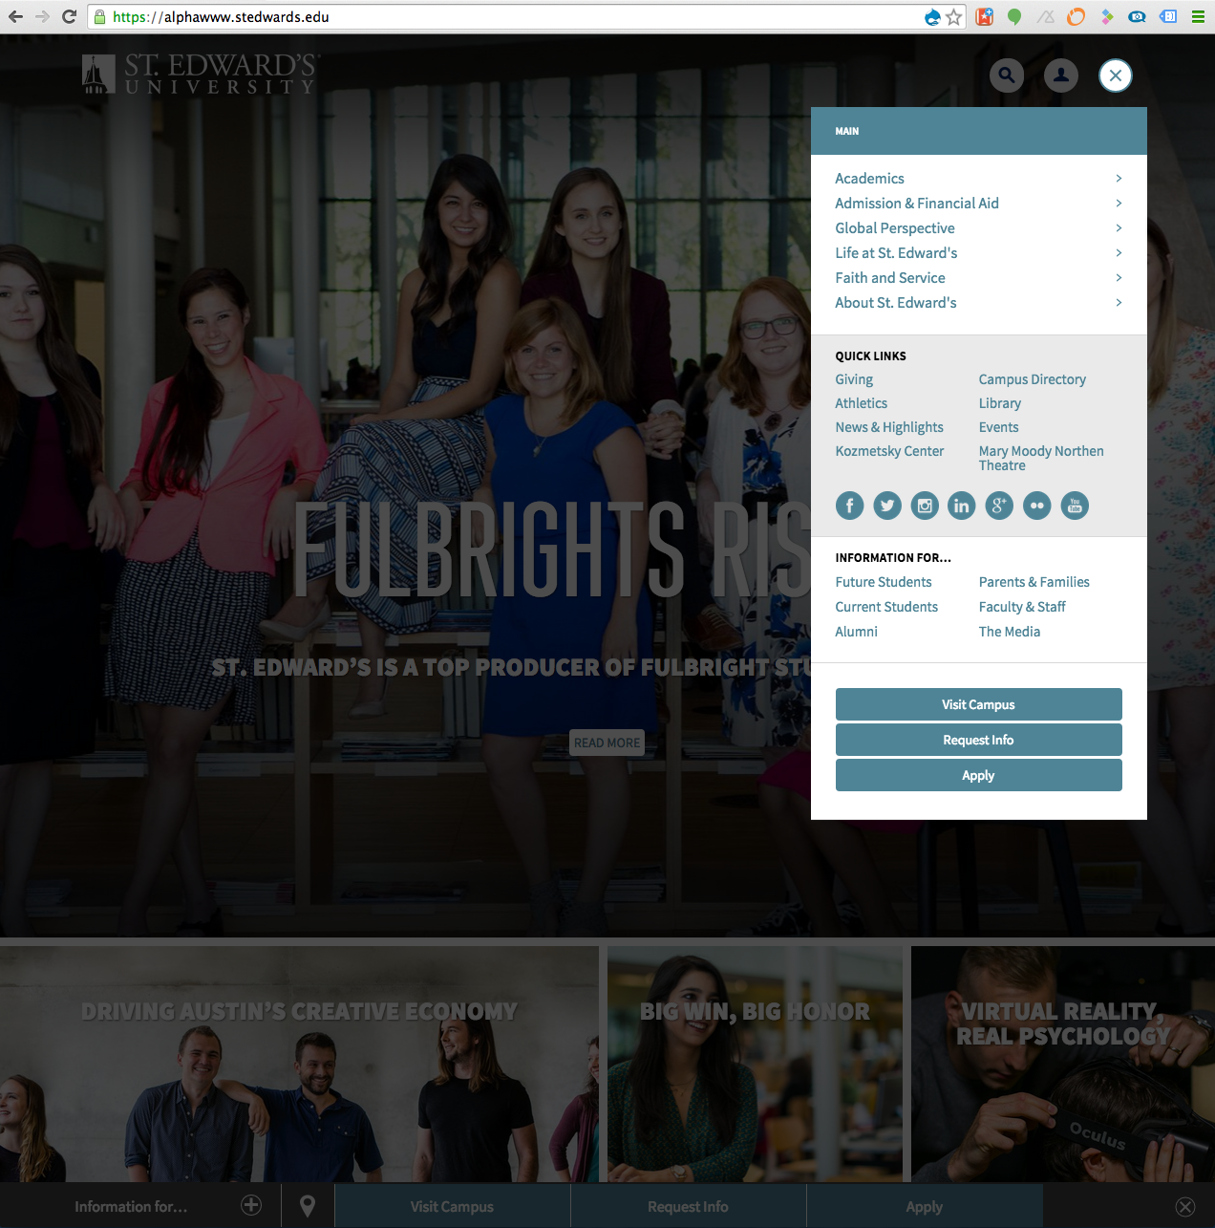
5) Search  Uses Google Custom Search to find relevant information quickly.  6) Login  Provides access to third-party transaction websites that require a login. Also provides links to Drupal-specific links and pages.  7) The Sticky Bar  Called the ‘sticky bar’ because it sticks to the bottom of the browser, this bar provides access to the audience gateways, Contact Us page, and the CTAs. This bar can collapse out of the way if users click the X on the far right. | 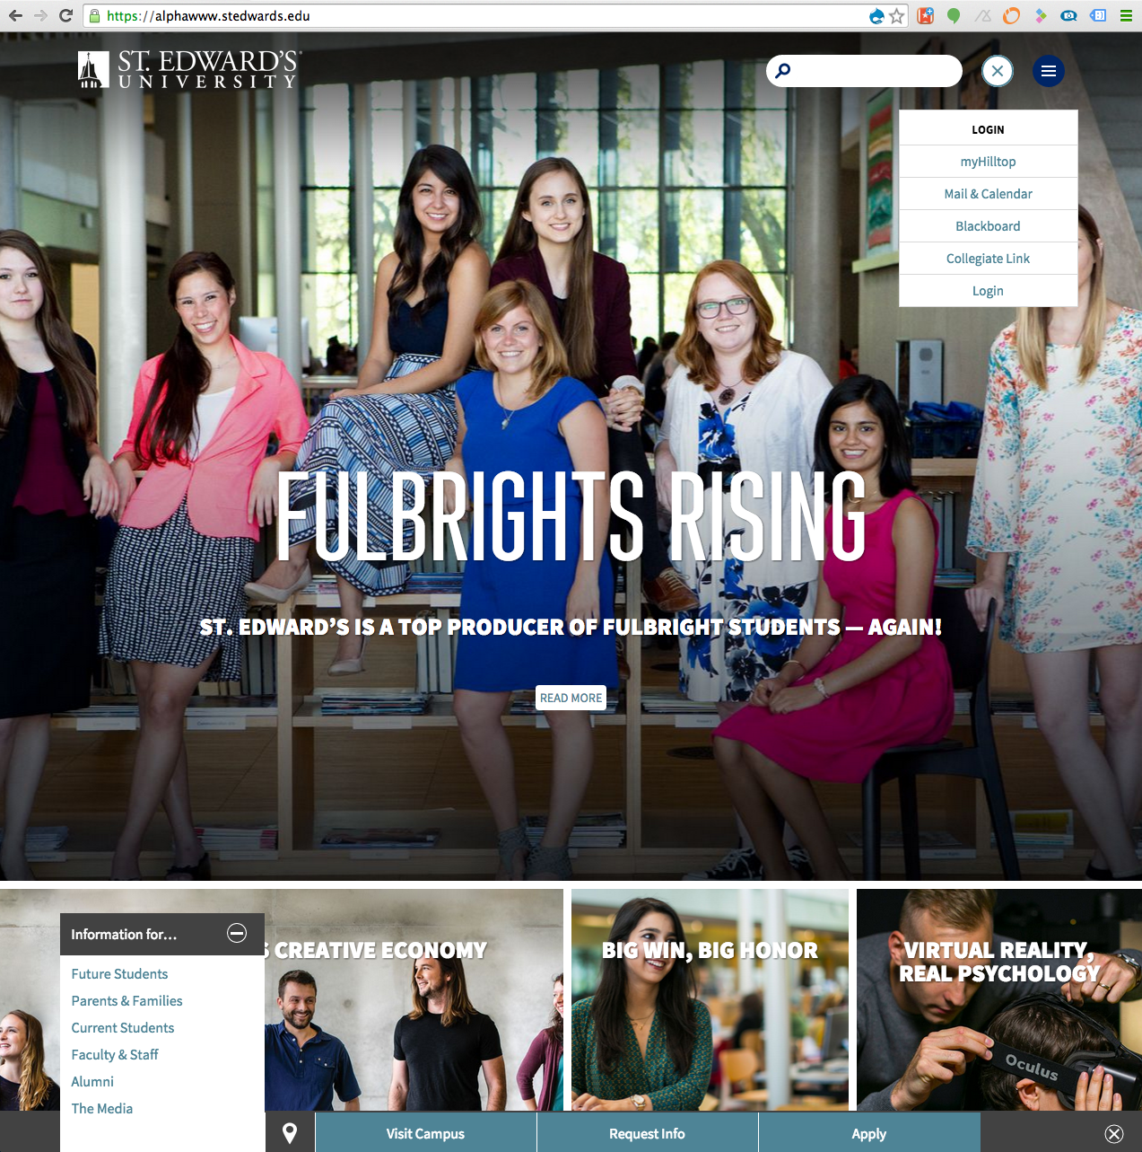

Sample Faculty Profile Page
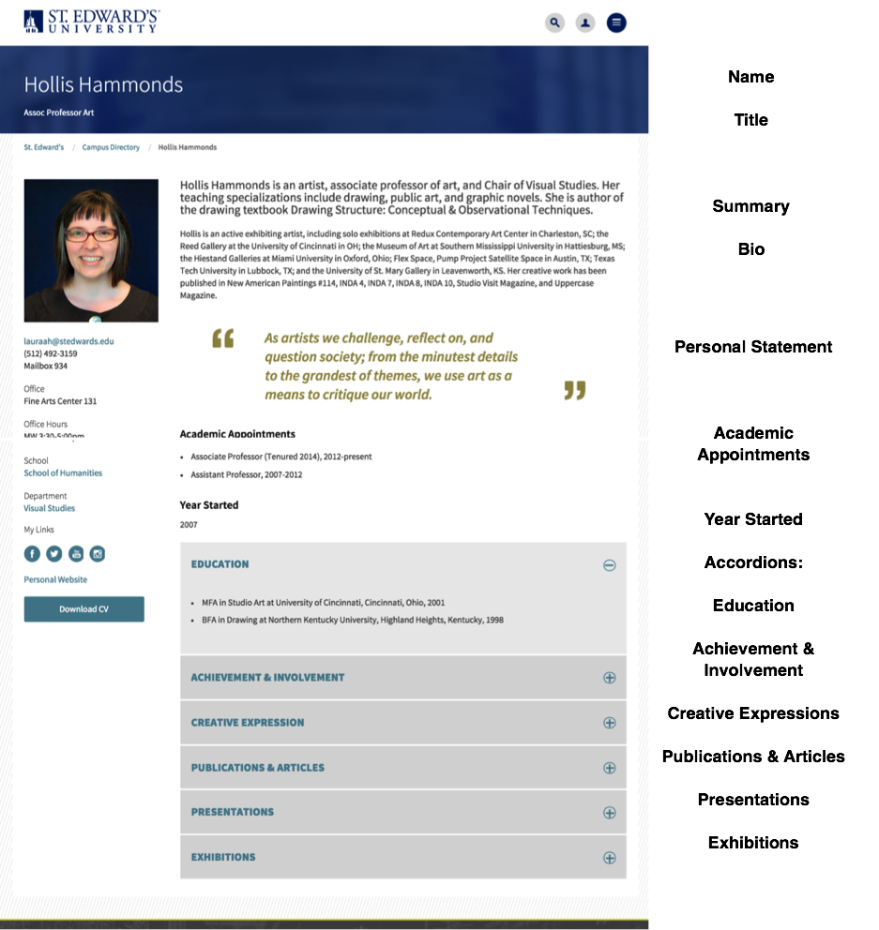

Left Column Items (Top to Bottom):
- Image
- Email
- Phone
- Mailbox
- Office
- Office Hours
- School
- Department
- My Links
- CV

How-to Guide

Finding your Profile

1. Visit the Campus Directory. Type in the URL directly, or... | 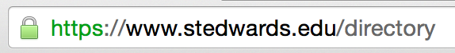
...using the hamburger menu (upper right corner), and click on Campus Directory (located under the Quick Links). | 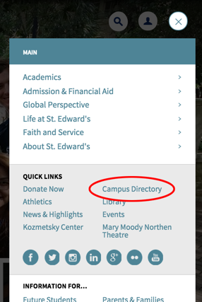
2. Search for your name in the search field  (use your first and/or last name) and then click “Search Directory”. | 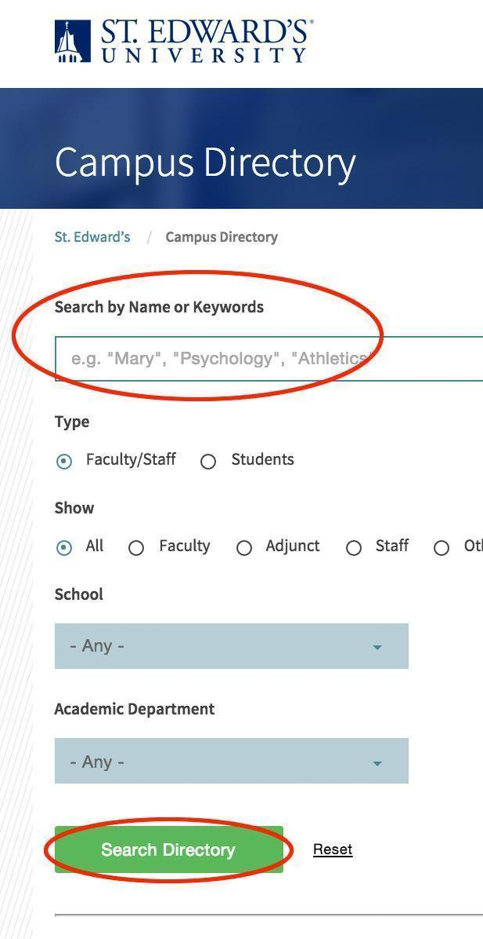
3. Locate your name in the results and click on your name to visit your profile page. | 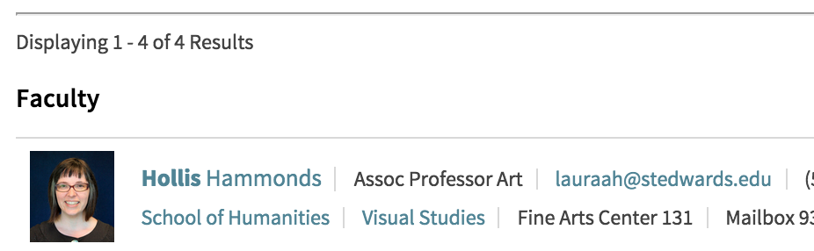

“Public” View: | 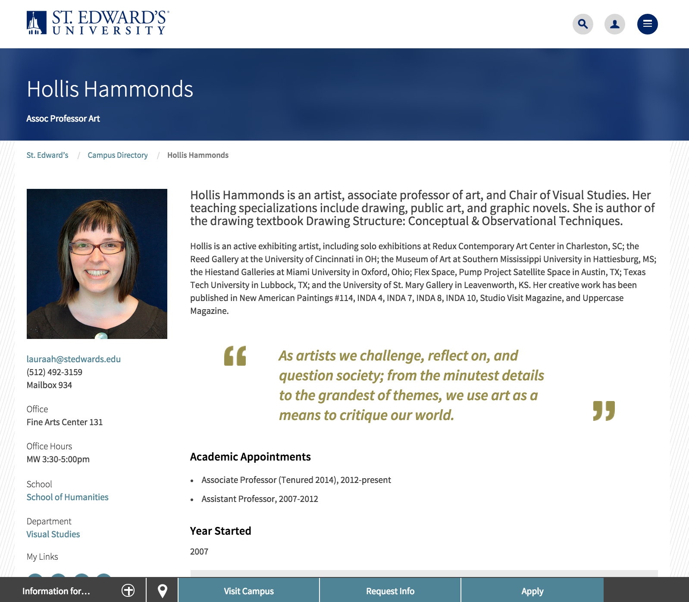
“Edit” View: | 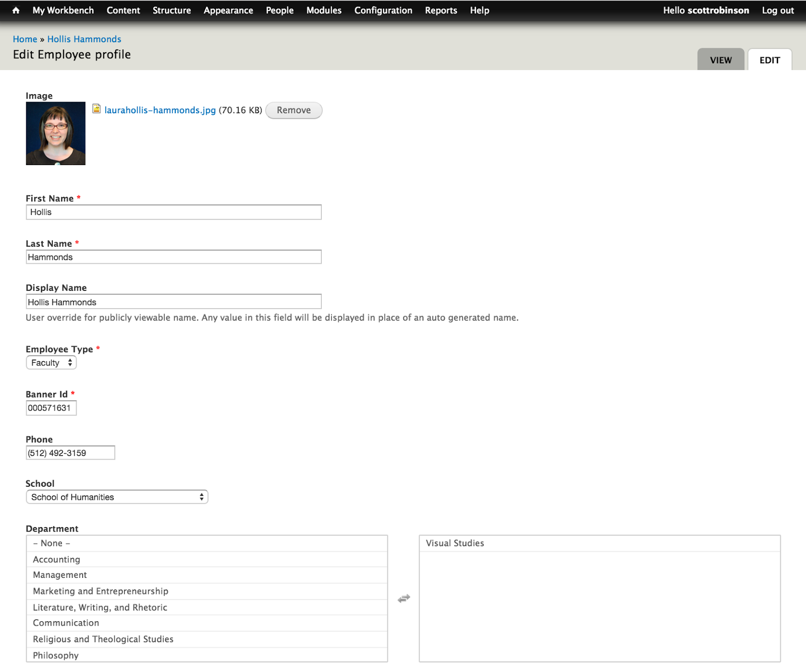

Editing your Profile

1. Visit https://www.stedwards.edu | 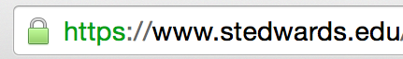
2. Click on the User Menu and then click on Log In | 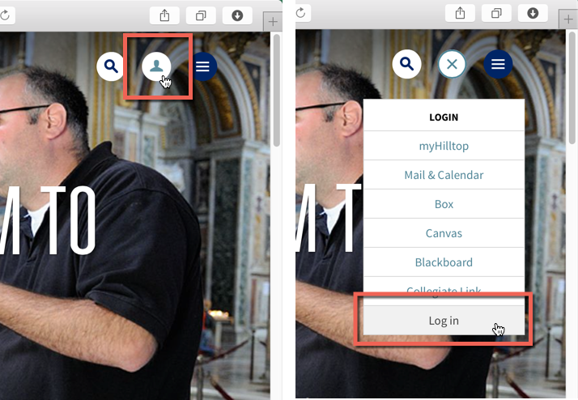
3. Log in using your St. Edward’s username and password | 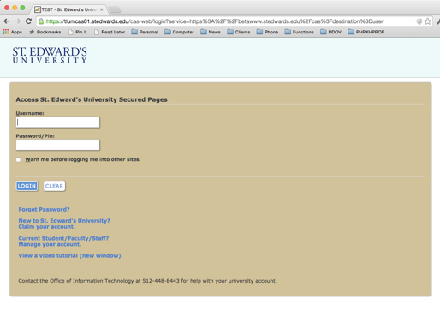
4. Click on the User Menu and then click on My Profile | 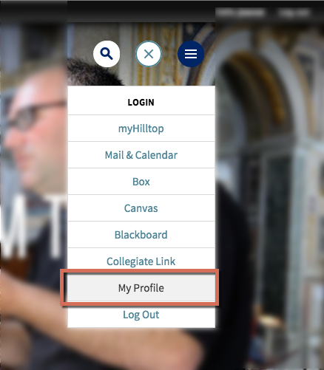
5. Just above the breadcrumb navigation, click “Edit” button. | 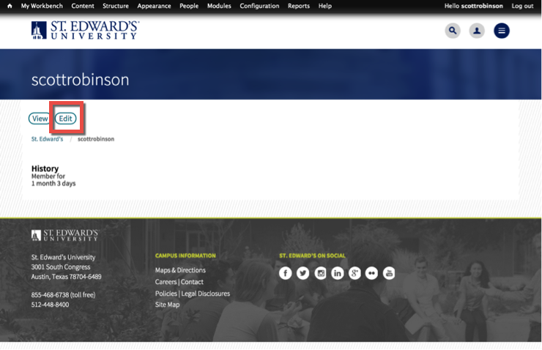
6. You will see your profile and the fields that you can edit. Scroll down to the area you wish to edit and modify the information.

7. FINAL STEP: Click SAVE*  *IMPORTANT: Unless the save button is clicked, your edits will not be saved and your work will be lost. | 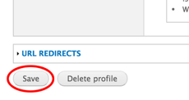

FAQs

Q. Who is responsible for updating my profile?
A. Every faculty member is responsible for the accuracy and quality of their profile information.

Q. How quickly will my edits appear on the website?
A. Immediately.

Q. How often should I update my profile?
A. Once a semester.

Q. Can someone else edit my profile?
A. Yes. Members of the web team have access to update your profile.

Q. Can you automatically update my office hours? My CV?
A. No, not at this time. We are continuing to investigate ways to feed in this information.

Q. How often does it sync with Banner?
A. Every night the campus directory data and banner are synchronized.

Q. Is it required to have my photo on my profile?
A. Excluding unique situations, yes. Faculty who do not wish to have their photo posted should discuss with your dean.

Q. Can I provide my own photo?
A. No. The photography will be official university photos. The marketing department provides an opportunity at the beginning of every new semester to take a new “head shot”. Please contact marketing at marketing@stedwards.edu if you’d like to be included in the next photo shoot.

